YOLOv3
This document explains how to set up, train, and evaluate YOLOv3 using a custom dataset. The following sections are included:
- Introduction
- Installation & Setup
- Dataset Preparation & Configuration
- Downloading Pre-trained Weights & Configuration Files
- Training
- Evaluation & Inference

1. Introduction
What is Darknet?
Darknet is an open-source neural network framework written in C and CUDA. It is specifically designed for real-time object detection and is best known for its use with the YOLO (You Only Look Once) series of object detectors. In this report, we use Darknet with the YOLOv3 architecture.
Why use Darknet?
- Speed & Efficiency: Darknet is optimized in C/CUDA, offering fast training and inference.
- Simplicity: With minimal dependencies, it is easy to compile and run on different platforms.
- Real-Time Detection: YOLOv3 implemented on Darknet can perform real-time object detection on videos and images.
- Flexibility: Supports both CPU and GPU mode with optional configurations such as enabling OpenCV, CUDA, and cuDNN.
Applications of Darknet YOLOv3
- Surveillance: Real-time monitoring and security systems.
- Autonomous Vehicles: Detecting pedestrians, vehicles, and obstacles.
- Retail: Customer behavior analysis and inventory monitoring.
- Industrial Automation: Quality control and anomaly detection.
- Custom Object Detection: Easily adaptable for specialized tasks (e.g., battery detection as shown in this report).

2. Installation & Setup
Clone the Darknet Repository and Build the Framework
- Clone the Repository:
# Clone Darknet from the official repository
!git clone https://github.com/AlexeyAB/darknet.git
%cd darknet
- Modify the Makefile to Enable OpenCV, GPU, and cuDNN:
The following commands modify the Makefile to:
  - Enable OpenCV (for image I/O and visualization)
  - Enable GPU support (for faster computations)
  - Enable cuDNN (for optimized deep learning operations)
!sed -i 's/OPENCV=0/OPENCV=1/' Makefile
!sed -i 's/GPU=0/GPU=1/' Makefile
!sed -i 's/CUDNN=0/CUDNN=1/' Makefile
!sed -i 's/CUDNN_HALF=1/CUDNN_HALF=0/' Makefile

- Compile Darknet:
!make

- Verify Darknet Execution:
Running Darknet without parameters should display the help message:
!./darknet

3. Dataset Preparation & Configuration
Unzip and Explore the Dataset
- Extract the Dataset Zip File:
The dataset (in this example, for battery detection) is provided as a ZIP file. Unzip it into a designated folder.
import zipfile
zip_path = "/content/battery detection 2.v5i.darknet.zip" # Adjust the path as needed
output_path = "/content/dataset"
with zipfile.ZipFile(zip_path, 'r') as zip_ref:
zip_ref.extractall(output_path)

- List Extracted Files:
import os
dataset_path = "/content/dataset" # Path to the extracted dataset
files = os.listdir(dataset_path)
print("Extracted files:", files)

Create Configuration Files for Object Detection
- Define Object Classes:
Create a file named obj.names that lists the class names (one per line). For example:
classes = ["9V", "coincell", "drycell"] # Replace with your actual class names
with open("/content/dataset/obj.names", "w") as f:
f.write("\n".join(classes))
print("obj.names created!")

- Create the Data File:
Create a file named obj.data to define key parameters and file paths for training. This file contains:
  - Number of classes
  - Paths to training and validation lists
  - Path to obj.names
  - Directory for saving backup weights
obj_data_content = """\
classes=3
train=/content/dataset/train.txt
valid=/content/dataset/valid.txt
names=/content/dataset/obj.names
backup=/content/dataset/backup/
"""
with open("/content/dataset/obj.data", "w") as f:
f.write(obj_data_content)
print("obj.data created!")

- Create Backup Directory:
Ensure that the backup directory exists for saving intermediate weights during training.
import os
backup_dir = '/content/dataset/backup/'
if not os.path.exists(backup_dir):
os.makedirs(backup_dir)

- Verify Dataset Structure:
Print the directory structure to verify that files are correctly organized.
for root, dirs, files in os.walk(dataset_path):
print(f"Directory: {root}")
print(f"Subdirectories: {dirs}")
print(f"Files: {files}\n")

Generate Image Lists for Training, Validation, and Testing
Using Python and glob, collect paths for images and write them into text files.
import glob
import os
# Define directories for train, valid, and test images
base_path = "/content/dataset"
train_dir = os.path.join(base_path, "train")
valid_dir = os.path.join(base_path, "valid")
test_dir = os.path.join(base_path, "test")
# Collect image paths (assuming images are in JPG format)
train_images = glob.glob(os.path.join(train_dir, "*.jpg"))
valid_images = glob.glob(os.path.join(valid_dir, "*.jpg"))
test_images = glob.glob(os.path.join(test_dir, "*.jpg"))
# Write image paths to corresponding text files
with open(os.path.join(base_path, "train.txt"), "w") as f:
f.write("\n".join(train_images))
with open(os.path.join(base_path, "valid.txt"), "w") as f:
f.write("\n".join(valid_images))
with open(os.path.join(base_path, "test.txt"), "w") as f:
f.write("\n".join(test_images))
print(f"train.txt created with {len(train_images)} images!")
print(f"valid.txt created with {len(valid_images)} images!")
print(f"test.txt created with {len(test_images)} images!")

4. Downloading Pre-trained Weights & Configuration Files
Download Pre-trained Convolutional Weights
Download the Darknet53 convolutional weights which will be used for transfer learning:
!wget https://pjreddie.com/media/files/darknet53.conv.74 -P /content/dataset/
Download YOLOv3 Weights (Optional)
You can also download the full YOLOv3 weights if you want to perform inference without custom training:
!wget https://pjreddie.com/media/files/yolov3.weights
Copy the YOLOv3 Configuration File
Copy the YOLOv3 configuration file from the Darknet repository to your dataset folder:
!cp cfg/yolov3.cfg /content/dataset/yolov3.cfg
• Modify 'yolov3.cfg'.
• Set batch size = 64 and subdivisions = 16.
• Adjust max_batches to classes * 2000 (minimum 4000).
• Set training steps at 80% and 90% of max_batches.
For yolo layer set classes = (no of classes) and for above convolution layer’s filters
Formula:
filters=(classes+ 5)*3
So if classes=1 then should be filter=18 and if classes=2 then its 21

5. Training
With the dataset prepared and configuration files in place, you can now start training the YOLOv3 model on Darknet.
Training Command
Change directory to Darknet (if not already) and run the training command. This command uses:
- The obj.data file for data configuration.
- The yolov3.cfg file for network configuration.
- Pre-trained weights (darknet53.conv.74) to initialize the network.
%cd /content/darknet
!./darknet detector train /content/dataset/obj.data /content/dataset/yolov3.cfg /content/dataset/darknet53.conv.74 -dont_show -map
During training, you will see metrics such as loss, mAP (mean Average Precision), and learning rate printed periodically. The training process will periodically save weights in the /content/dataset/backup/ folder (e.g., yolov3_6000.weights, yolov3_last.weights, and yolov3_final.weights).
Tip: To restart training from scratch, add the -clear flag at the end of the training command.

6. Evaluation & Inference & Visualizing results
Evaluate Model Performance
During training, Darknet prints out mAP and other metrics. An example output for mAP calculation might look like:
class_id = 0, name = 9V, ap = 91.85%
class_id = 1, name = coincell, ap = 90.52%
class_id = 2, name = drycell, ap = 94.83%
mean average precision (mAP@0.50) = 0.924017, or 92.40 %
These metrics provide insight into the performance of your detector on each class and overall.

Run Inference on a Test Image
After training, you can run the detector on a test image to visualize the results. For example:
!./darknet detector test /content/dataset/obj.data /content/dataset/yolov3.cfg /content/dataset/backup/yolov3_best.weights /content/dataset/test/IMG_0935_.jpg
This command:
- Loads the best weights (in this case, yolov3_best.weights).
- Runs the detector on the specified test image.
- Displays or saves the resulting image with detected bounding boxes and labels.
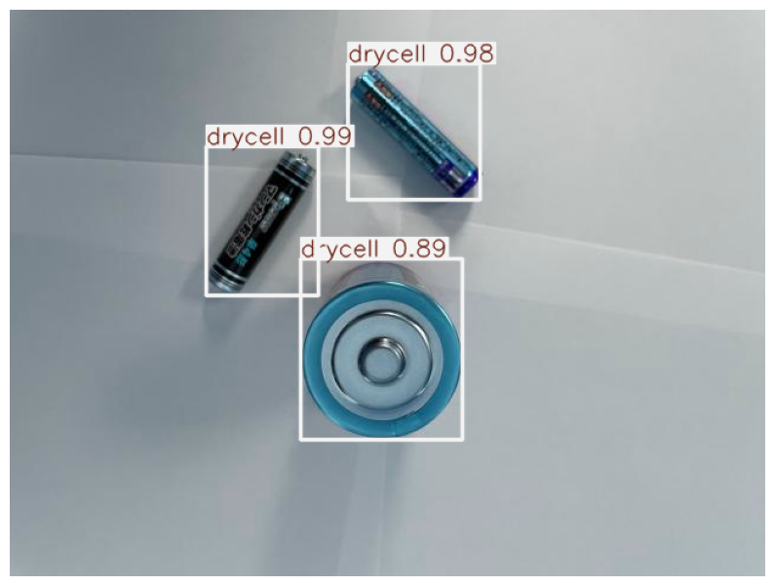
Inference Time: 1 second per image (image size:640x640)

